There are 5 members in our team: Amairani Aguilera, Jesus Daniel Reveles, Travis Piwetz, Laura Palacios, James Rayford. The team model we used was a democratic egoless team.

Diagrams used are down below.

-Use Case Diagram

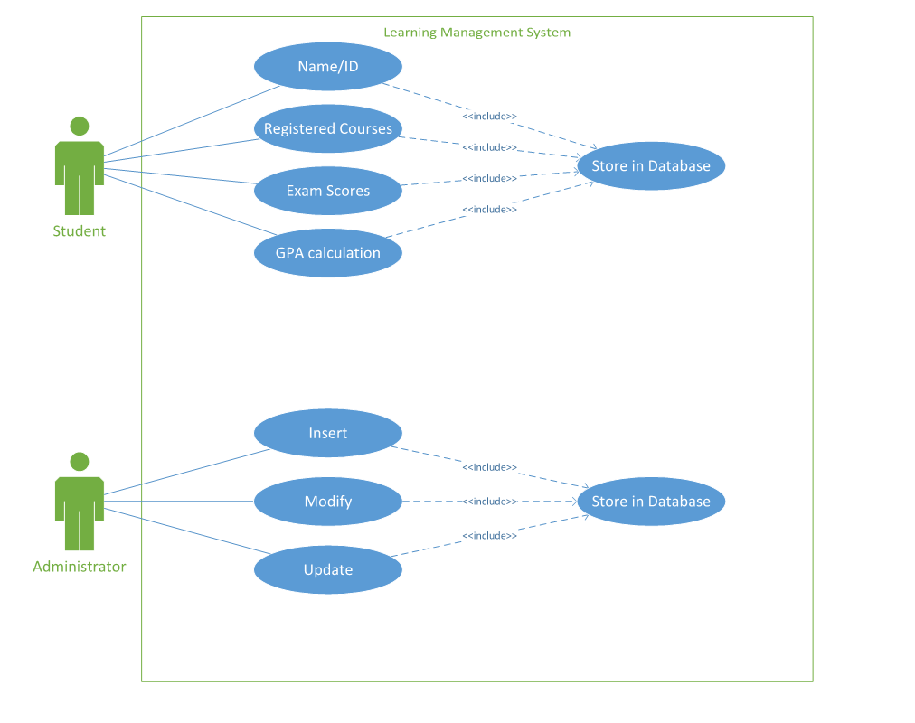

-Class Diagram

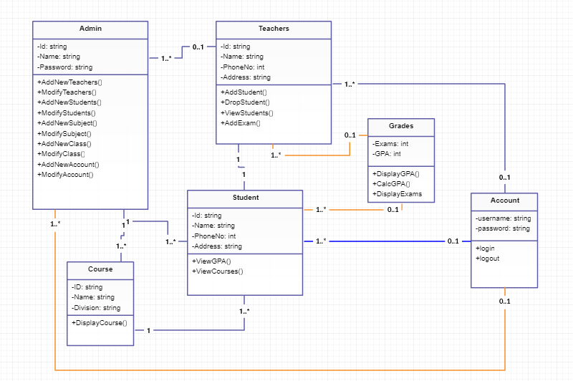

-UML

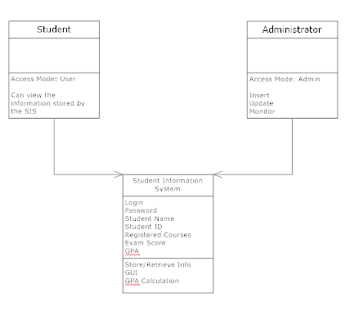

-CRC Card

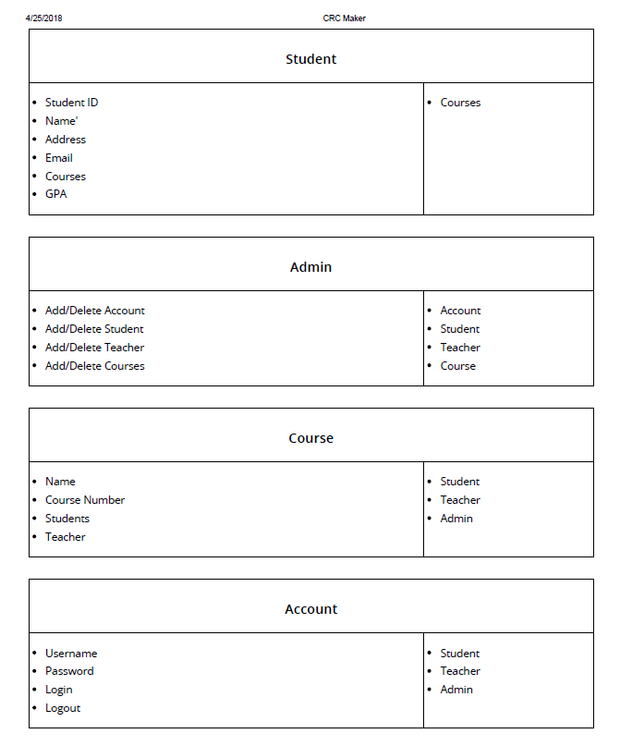



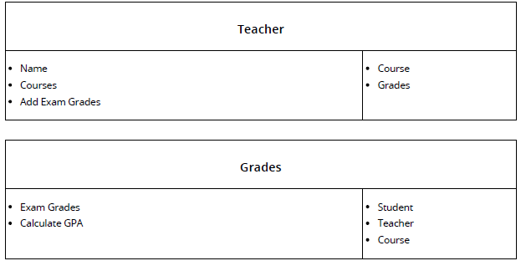

-Prototype for basic requirements

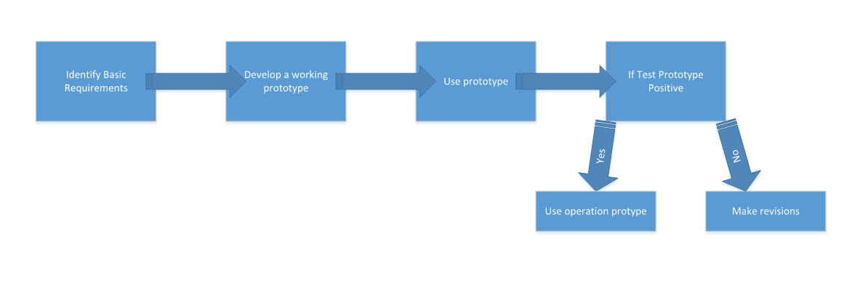

-Sequence and Interaction Diagram

